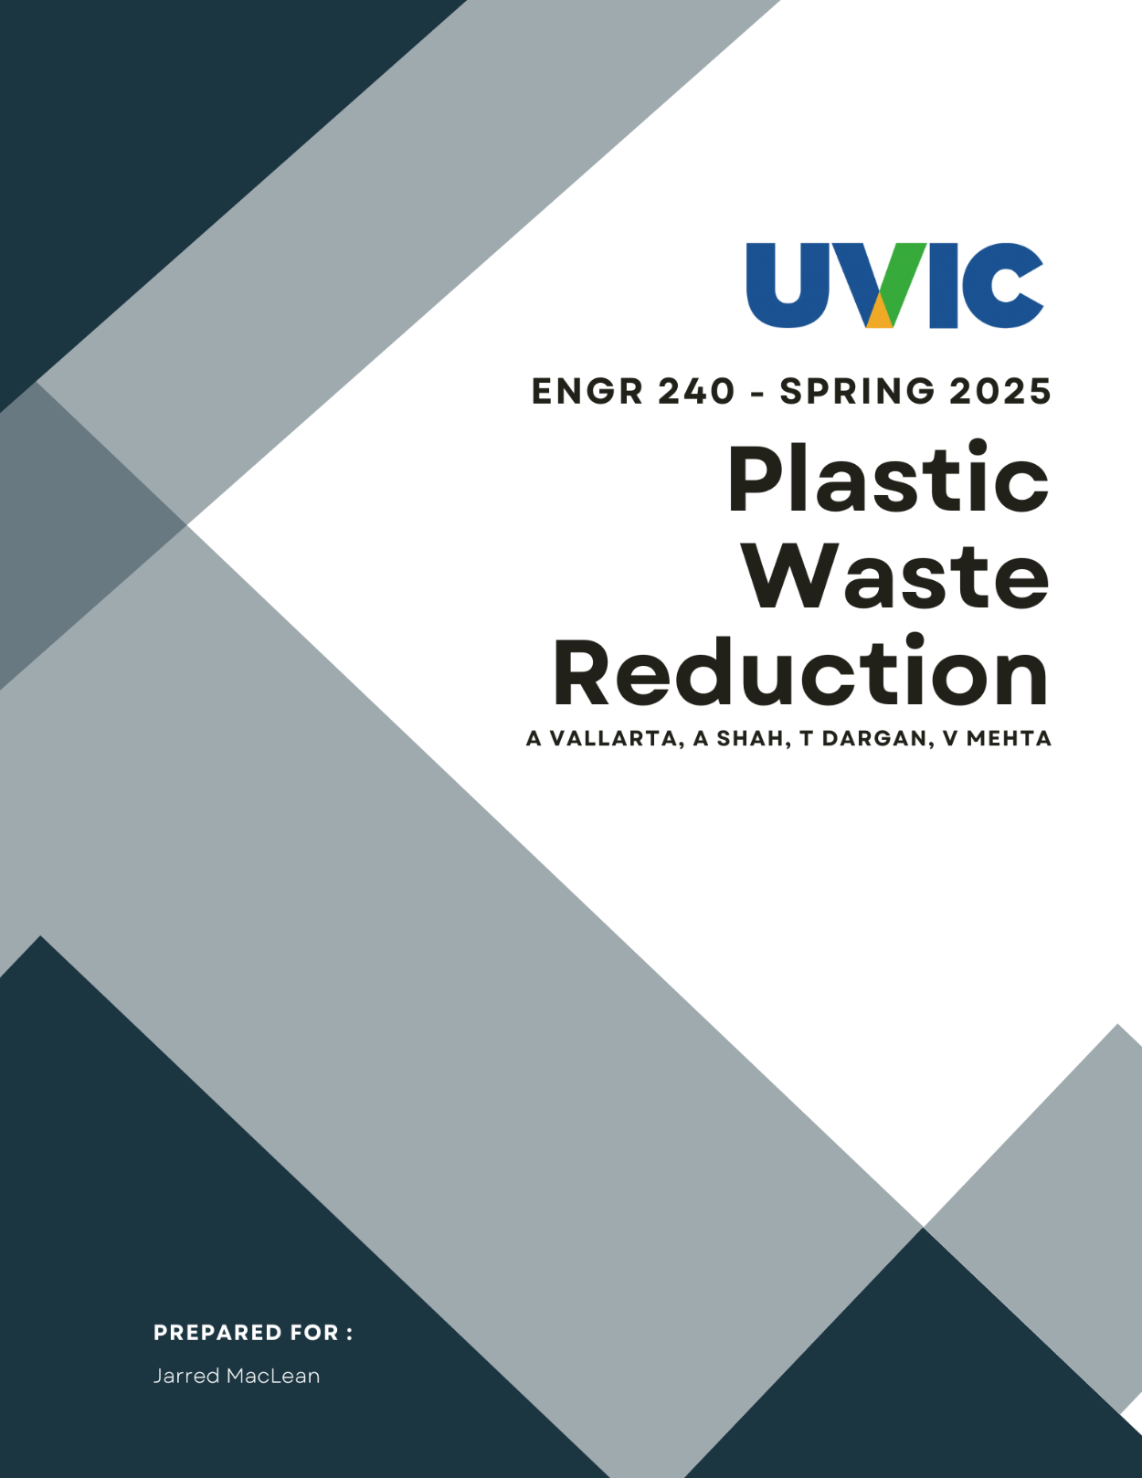

1. Client Background 3

2. Executive Summary 5

3. Problem Definition 5

i. Need Statement 5

ii. Goal Statement 5

iii. Objectives 5

iv. Constraints 5

v. Benefits 5

4. Plan of Action 5

i. Technical Plan 5

ii. Management Plan 5

5. Budget 5

6. Qualification 5

7. Campus Waste & Identify Benefits 5

8. RVM Model Evaluation & Site Survey 5

9. Results 5

10. Feedback and Stakeholder Engagement 5

11. Findings 5

12. Results 5

13. Conclusion 5

References 6

Appendices 7

This proposal examines the feasibility of using camera-assisted object identification to automate waste sorting on campus. By integrating a Raspberry Pi camera system with existing waste bins, the technology will direct trash into the appropriate compartments, thereby reducing the manual sorting workload for waste management staff.

## Client Background

The University of Victoria (UVic) is globally recognized as a leader in sustainability, ranking second in Canada and fourth worldwide for promoting sustainable cities and communities[1]. Between 2009 and 2018, UVic increased its landfill diversion rate from 58% to 74% through effective recycling and composting initiatives[2]. However, to achieve its ambitious goal of an 81% diversion rate as outlined in the university’s latest Strategic Plan[3], additional innovative methods are needed to address the challenge of plastic and improperly sorted waste, which currently accounts for 18% of landfill trash2. With the impending closure of Hartland Landfill in 2040[4], UVic faces mounting pressure to enhance its waste management systems to reduce environmental and financial impacts. Working together with neighborhood associations and government may also yield insightful information and useful resources to support the institution in achieving its sustainability objectives. More incentives for staff and students to use reusable items, including school dining discounts for bringing their own containers, could help lessen the usage of single-use plastics.

## Executive Summary

## Problem Definition

### Need Statement

### Goal Statement

### Objectives

### Constraints

### Benefits

## Plan of Action

### Technical Plan

### Management Plan

## Budget

## Qualification

## Campus Waste & Identify Benefits

## RVM Model Evaluation & Site Survey

## Results

## Feedback and Stakeholder Engagement

## Findings

## Results

## Conclusion

## References

[1] “UVic a national leader in climate and sustainability,” *UVic News*, Jun. 12, 2024. [Online]. Available: <https://www.uvic.ca/news/topics/2024+the-global-impact-rankings+mediarelease#:~:text=UVic%20is%20ranked%20second%20in,and%20communities%20(SDG%2011)>. Accessed: Mar. 11, 2025.

[2] University of Victoria, *Waste to Resource Assessment™ Report*. [Online]. Available: <https://www.uvic.ca/facilities/assets/docs/UVic-waste-assessment-report.pdf>. Accessed: Mar. 11, 2025.

[3] University of Victoria, *Distinctly UVic: A strategy for the University of Victoria*. [Online]. Available: <https://www.uvic.ca/strategic-plan/_assets/docs/uvic-strategic-plan-2023.pdf>. Accessed: Mar. 11, 2025.

[4] J. MacLean, “Request for Proposals FM/WR 0520,” University of Victoria, Victoria, BC, Canada, 2024. Accessed: Mar. 11, 2025.

[5] University of Victoria, *Climate and Sustainability Action Plan 2030*. [Online]. Available: <https://www.uvic.ca/_assets/docs/csap2030-actions.pdf>. Accessed: Mar. 11, 2025.

## Appendices

1. “UVic a national leader in climate and sustainability,” *UVic News*, Jun. 12, 2024.

   [Online]. Available: <https://www.uvic.ca/news/topics/2024+the-global-impact-rankings+mediarelease#:~:text=UVic%20is%20ranked%20second%20in,and%20communities%20(SDG%2011)>. Accessed: Mar. 11, 2025.
2. University of Victoria, *Waste to Resource Assessment™ Report*. [Online]. Available: <https://www.uvic.ca/facilities/assets/docs/UVic-waste-assessment-report.pdf>. Accessed: Mar. 11, 2025.
3. University of Victoria, *Distinctly UVic: A strategy for the University of Victoria*. [Online]. Available: <https://www.uvic.ca/strategic-plan/_assets/docs/uvic-strategic-plan-2023.pdf>. Accessed: Mar. 11, 2025.
4. J. MacLean, “Request for Proposals FM/WR 0520,” University of Victoria, Victoria, BC, Canada, 2024. Accessed: Mar. 11, 2025.